*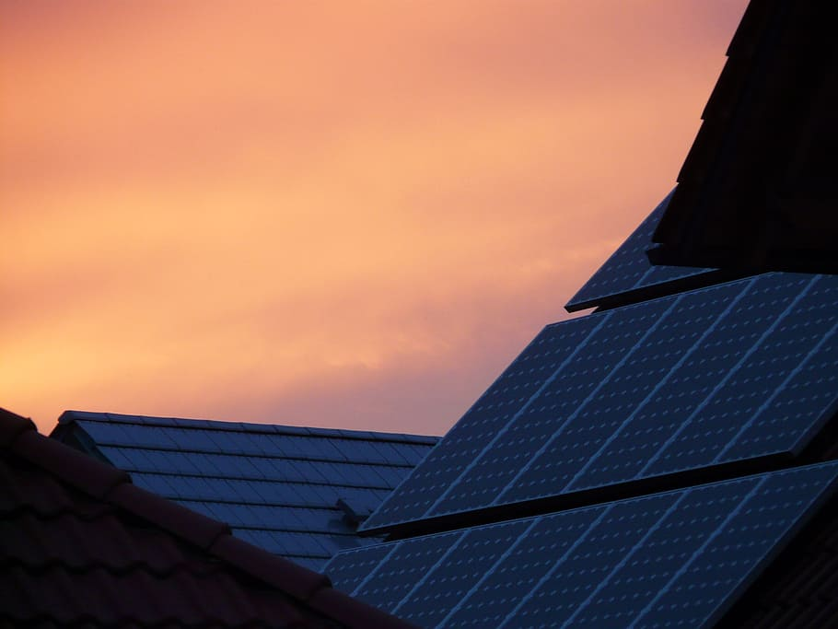*

*Legal Disclaimer for United Texas Solar*.

The material provided on this site (www.UnitedTexasSolar.com) is provided by way of information only. It is not and does not purport to be legal or other advice. While we endeavor to ensure that the contents of the site are accurate, errors or omissions may occur and we do not accept any liability in respect of them. Any links provided on the site are provided for your convenience – their inclusion does not imply any approval or endorsement by us. We have no control over the content of those sites and accept no responsibility or liability in respect of them. Solar Energy is Electric and can be stored in batteries or used as it is made. Like any electric device the chance for an electrical fire can occur anytime. Animals chewing wiring, or other problems that can arise to cause shortages or sparks in the system. Solar has measures in the system to limit this chance, but in no way is anything 100%. We at United Texas Solar, educate and supply individuals with common knowledge of information regarding solar, but in no way do we take responsibility for any such events that can occur with solar energy or a solar system. We provide individuals with information and then allow them to sign for their installation with a solar installer in the area to handle their install.